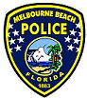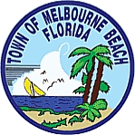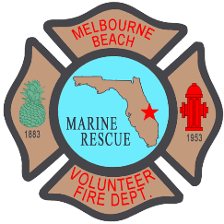
TOWN OF MELBOURNE BEACH 2021 FOUNDERS DAY
138 Years Saturday May 1st, 2021 1883-2021

ARTS & CRAFTS SHOW IN RYCKMAN PARK – 8:00AM TO 5:00PM

ENTERTAINMENT SCHEDULE AT THE GAZEBOS

NOON – 1:30 PM DREW BARRY & MORE
1:30 PM – 3:00 PM BILLY CHAPMAN BAND
3:00 PM – 6:00 PM UNIT 5
6:00 PM – 9:00 PM LIZ AND THE INVIZ

COMMUNITY CENTER 11:00AM
PRESENTATION BY BRUCE MORGAN
OUR HISTORY OF PONCE DE LEON

FOOD VENDORS – 8:00AM – 9:00PM
BANGKOK STYLE THAI FOOD
BEACHIN BBQ CREW
COUNTRY KETTLERS KORN
DUSTY JOE’S SMOKIN EATS
HUNNYZ WINGZ N THINGZ
KONA ICE SOUTH PALM BAY
LENAND10 LLC
MOO’S SOFT SERVE
NAUTICAL CAFÉ

DRINK TICKETS SOLD 8:00 AM – 8:30 PM
NO SERVING AFTER 9:00PM
STREET CLOSINGS: Riverside Drive from Avenue A and Ocean Ave / Riverside Drive to Pine Street.
NO PARKING on First and Second Avenue from Pine Street to River Road
NO PARKING on Avenue A and Avenue B from Pine Street to Riverside Drive

