Tai Chi Fridays in Ryckman Park
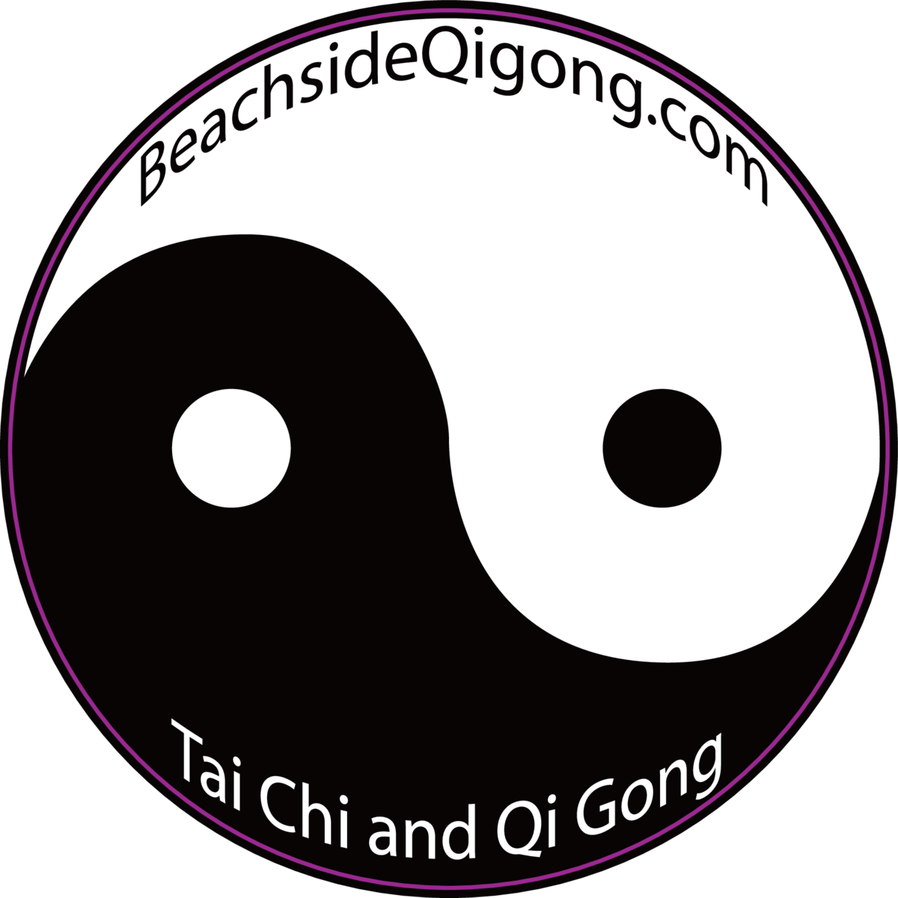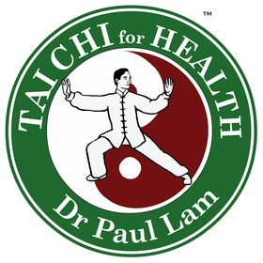
Tai Chi 1-Beginner Friendly

Basic, beginner class. Jump in at any time but to learn tai chi, consistent attendance is recommended. Each class includes breath work, qigong warm-up, flow of form, details of TC1 movement and cool-downs. Hundreds of studies on Tai chi show it improves physical and mental balance, reduces cellular oxidation, alleviates some respiratory ailments, boosts immunity, quiets anxiety and depression, improves cognitive ability, strengthens bones, joints & muscles, strengthens the core, increases athletic performance and overall focus.

The stretch of yoga, the focus of meditation and the aerobic health of breath work. Used throughout the world for centuries by athletes, monks, warriors, veterans, seniors, martial artists, children and those who want smart, evidence-based exercise.

Certified instructor Lea Williamson, ShiFu, Founder BeachsideQigong.com

We meet under the oak trees in the park, 509 Ocean Ave. The lot is metered. If it’s raining, we meet under the gazebo. Comfy clothes, no mat required (not yoga ;)

Questions: BeachsideQi@gmail.com. More info: BeachsideQigong.com

STARTS FRIDAY, FEBRUARY 4th
9:30am-10:30am Tai Chi 1

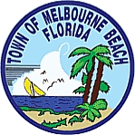
FREE classes courtesy of the
Town of Melbourne Beach

